Welcome to the **OzCode Workshop**!

Rejoice! You’re going to walk out of this workshop a certified debugger-guru-extraordinaire!

To get started, you’ll need to download and install OzCode v2.0.

Go to <http://www.oz-code.com> and click the “Try v2.0 Beta” button:



To take part of the practical part of this workshop, you will need Visual Studio 2013 installed.

In this workshop, we’ll be debugging two apps:

1. The OzCode Demo (after you install OzCode, you’ll have this on your computer,

at **%APPDATA%\CodeValue Ltd\OzCode\OzCodeDemo.sln**

1. The AnimalShelter app. This is a WPF for managing the dogs in various Animal Shelters.

This application is riddled with bugs, and our customers (the Animal Shelter people) are furious.

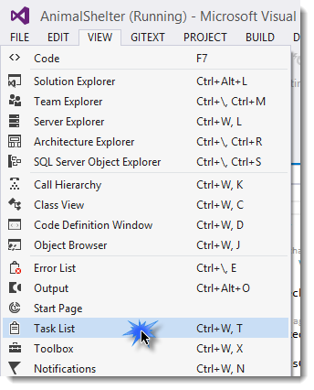Now, you’re going to fix it! ☺

Go to: [http:/www.github.com/arielbh/animalshelter](http://www.github.com/arielbh/animalshelter) and click the  button!

To get started, open up the Visual Studio Task List by going to View->Task List-<Comments to see the list of bugs we have to solve!

Here’s what’s planned:

1. **Introduction:** OzCode, the Psychology of Debugging, and You
2. **Demos:** Simplify, Predict, Search, HUD, Setter Breakpoint
3. **Independent work:** Fix Bugs #1-#7 in our buggy Animal Shelter app!
4. **Demos:** QuickAttach, Show All Instances, Trace, Foresee, Filter
5. **Independent Work:** OzCode Demo App
6. How We Built OzCode (Roslyn, BDDfy, oh my!)
7. **Final words and swag distribution**

**The Animal Shelter App – Oh So Many Bugs in such a Small App**

The client just called in with this list of bugs. She’s very upset – it feels like nothing is working!

To get started fixing each of these bugs, double click the bug in your Visual Studio Tasks list. You’ll get to the area in the code where the bug is hiding, and see some instructions on how to approach fixing it! 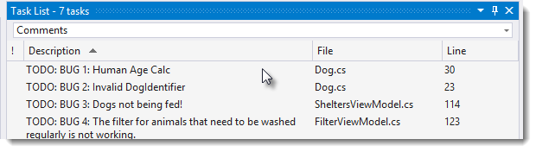

1. The application shows the age of each pet in Human years. However, this calculation is incorrect! It’s showing huge numbers that don’t make sense.

**To reproduce,** just start the app click on one of the dogs on the left hand side, and view its “Human Age”.

1. The global association of Animal Shelters requires each animal shelter to identify each and every pet using a *Dog Identifier* in the format of “**Id-Gender-Age-Breed-Name”**. However, the system is showing incorrect identifiers.

**To reproduce,** click on “Winston” in the list of dogs. His *Dog Identifier* should have been "2-Male-2-Bulldog-Winston” but appears as "13948Winston".

1. When clicking the “Which dogs need to be fed?” button, the result is always empty.

**To reproduce,** click “Shelters” at the top, and then click the “Which dogs need to be fed?” button.

1. When you add a filter on only dogs that need to be washed, the list comes back as empty! That can’t be right!

**To reproduce:** click “Dogs”, choose “Filters”, check “Needs to be washed”, and click the “Filter” button!

1. When you mark one of the dogs as a Favorite in the Dogs View, and then switch over to the Shelter view, the program “doesn’t remember” that you selected that dog as a favorite, and vice versa!

**To reproduce:** Star one of the dogs, switch to Shelters, and check if it starred there as well.

1. The button that tells the Animal Shelter owner what food rations to give each dog in any given day is broken! It’s telling us to starve out some of the dogs!

**To reproduce:** Click “Shelters”, then click “Show Food Rations”. You’ll see that for some dogs, we are being told to give them “0 grams” of food.